Contents

Amazon Linux 2 2

Intall Java: https://www.linode.com/docs/guides/how-to-install-openjdk-on-ubuntu-20-04/ 2

Install Maven: https://linuxize.com/post/how-to-install-apache-maven-on-ubuntu-20-04/ 2

Install Git 2

Downloads for Jenkins LINK 2

Install and run Jenkins 2

Jenkins Create a Project 3

Configure webhook. 4

Install Docker 5

Install sonarqube docker. 6

# Amazon Linux 2

# Intall Java: <https://www.linode.com/docs/guides/how-to-install-openjdk-on-ubuntu-20-04/>

# Install Maven: https://linuxize.com/post/how-to-install-apache-maven-on-ubuntu-20-04/

# Install Git

1. sudo apt install git
2. git -–version
3. git clone “my repo”
4. [Documentation](https://www.atlassian.com/es/git/tutorials/syncing/git-pull)

# Downloads for Jenkins [LINK](https://www.digitalocean.com/community/tutorials/how-to-install-jenkins-on-ubuntu-20-04-es)

1. $ wget -q -O — <https://pkg.jenkins.io/debian/jenkins-ci.org.key> | sudo apt-key add –
2. $ echo deb <https://pkg.jenkins.io/debian-stable> binary/ | sudo tee /etc/apt/sources.list.d/jenkins.list
3. $ sudo apt-get update
4. $ sudo apt-get install Jenkins
5. $ sudo systemctl start jenkins

# Install and run Jenkins

1. $ sudo apt-get install Jenkins
2. $ sudo systemctl start jenkins
3. sudo systemctl status jenkins
4. Check pass
   1. sudo cat /var/lib/jenkins/secrets/initialAdminPassword
5. Connect to http://<your_server_public_DNS>:8080 from your favorite browser.

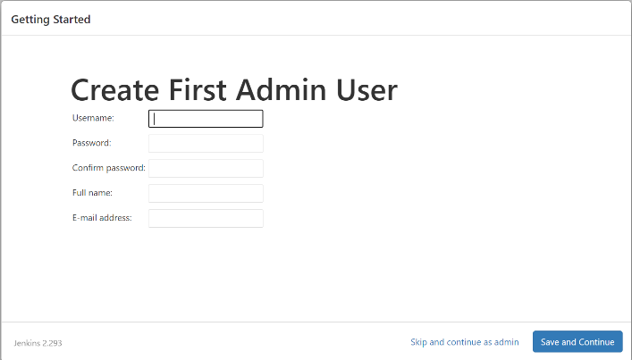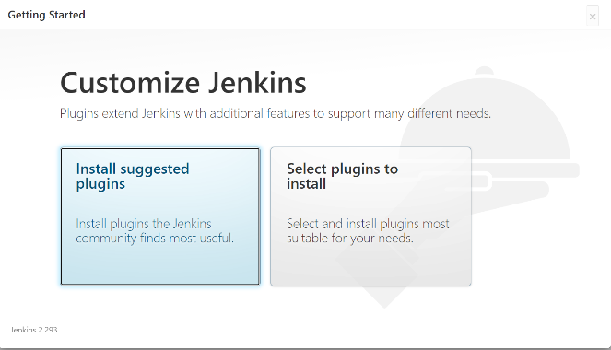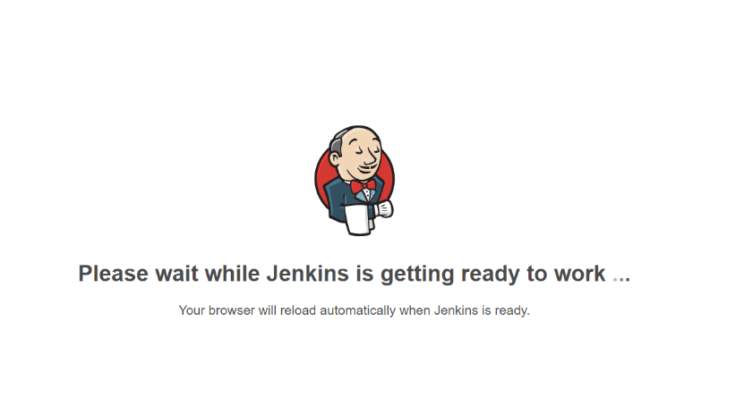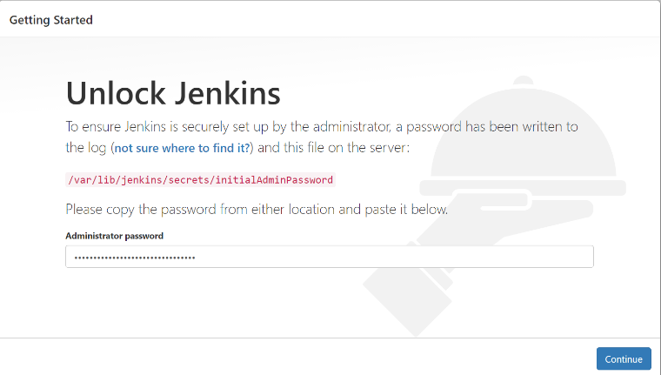

# Jenkins Create a Project

1. Enter New Item

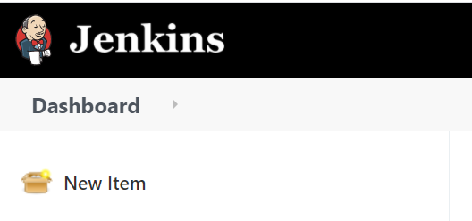

1. Enter the name, select Freestyle project and select OK.

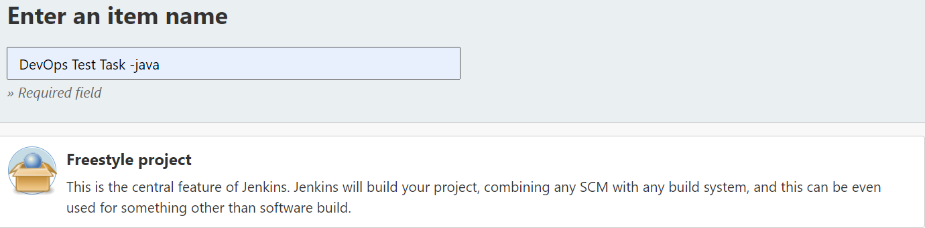

1. Enter a description

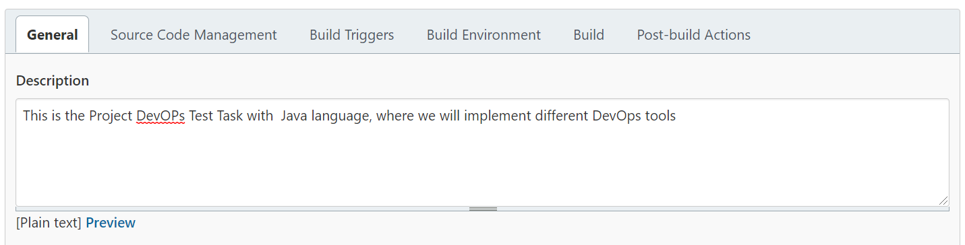

1. At Source code management inset your repository.

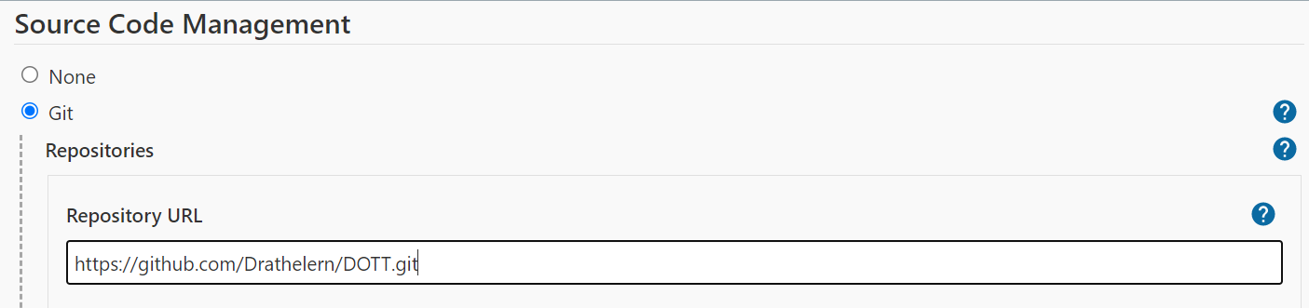

1. Add GitHub Hook Trigger for GITScm polling

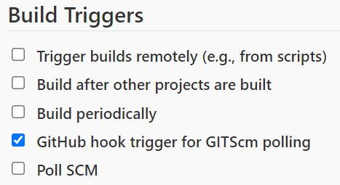

1. Select Apply and save.

# Configure [webhook](https://www.blazemeter.com/blog/how-to-integrate-your-github-repository-to-your-jenkins-project).

1. Go to repository to settings, select webhook and select add.

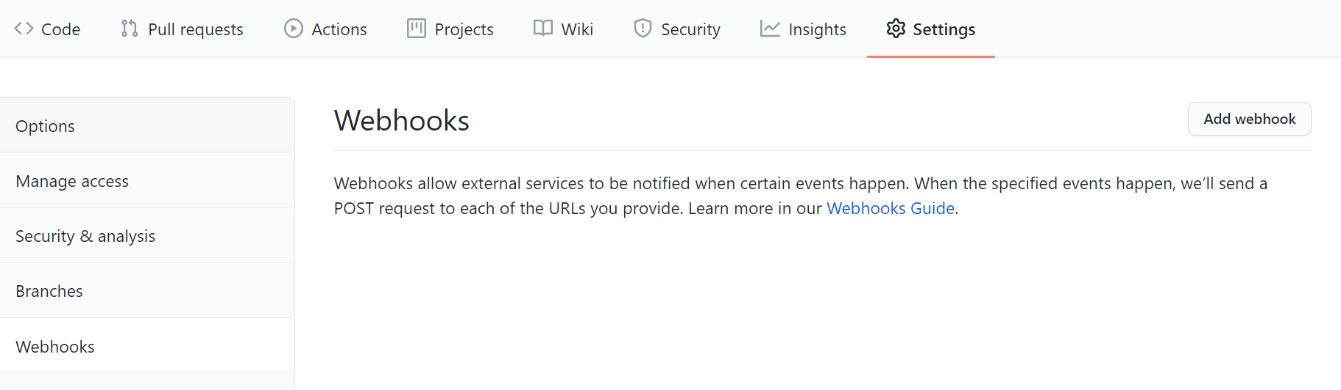

1. In the ‘Payload URL’ field, paste your Jenkins environment URL. At the end of this URL add /github-webhook/. In the ‘Content type’ select: ‘application/json’ and leave the ‘Secret’ field empty.

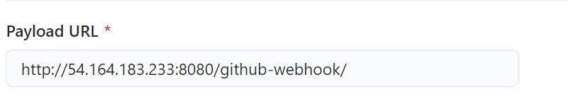

1. At Content Type select application/json

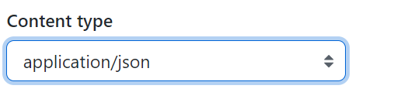

1. In Which events would you like to trigger this webhook?, select Let me select individual events, and add the options

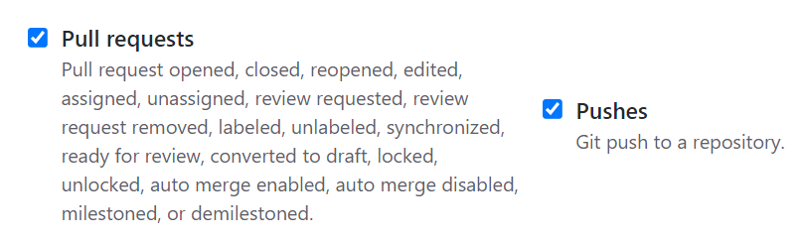

1. To finish press Add webhook.

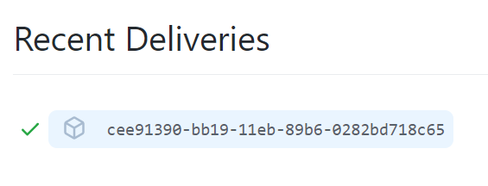

1. Test Webhook: Make a commit.
   1. Create a file

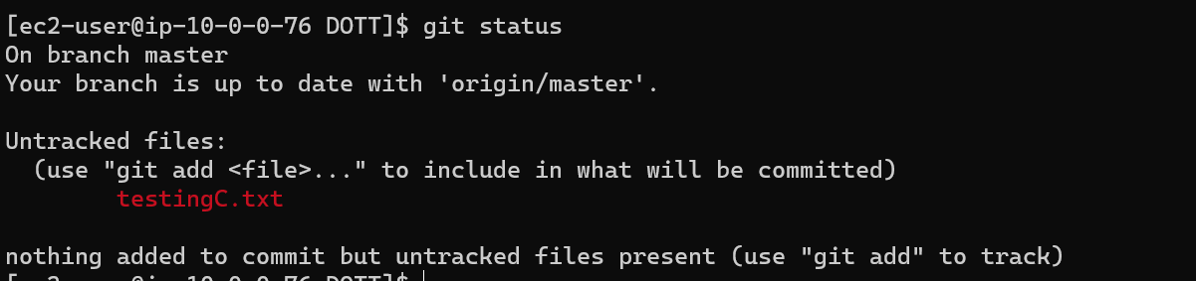

* 1. Make a commit.

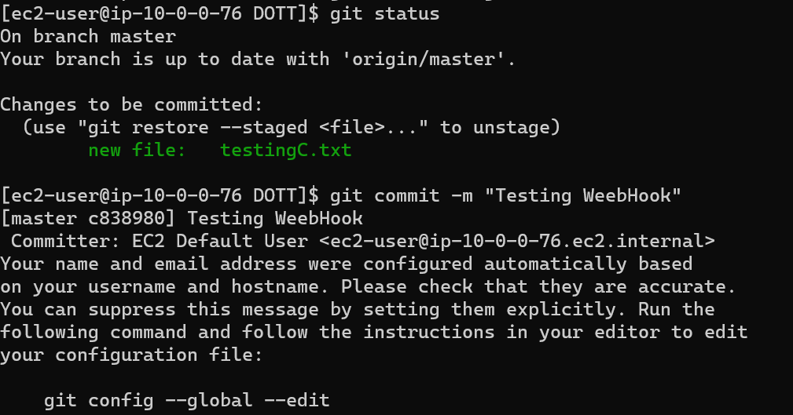

* 1. Push to the repository.

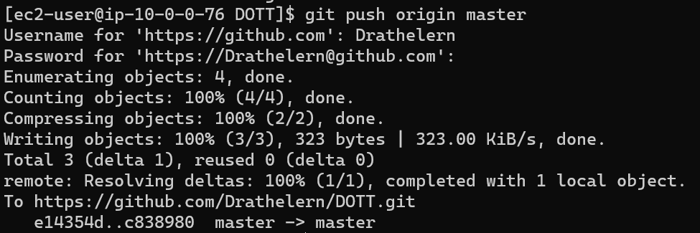

1. Check your auto build in Jenkins.

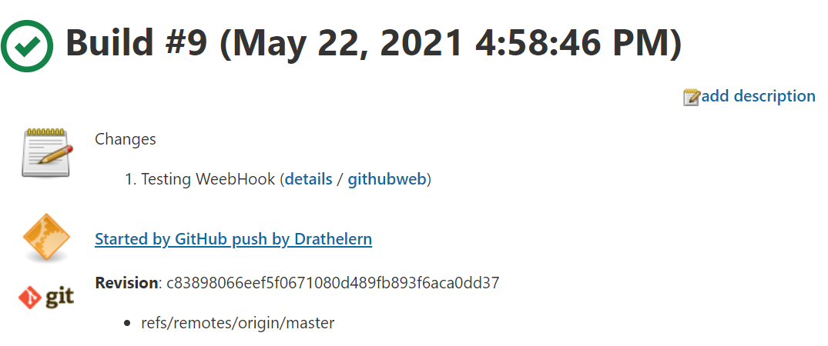

# Install Docker

1. sudo apt install apt-transport-https ca-certificates curl gnupg-agent software-properties-common 13 curl -fsSL <https://download.docker.com/linux/ubuntu/gpg> |
2. sudo apt-key add - 14
3. sudo add-apt-repository "deb [arch=amd64] https://download.docker.com/linux/ubuntu $(lsb_release -cs) stable" 15
4. sudo apt install docker-ce docker-ce-cli containerd.io 16
5. sudo apt update 17
6. sudo apt install docker-ce docker-ce-cli containerd.io 18
7. sudo apt update 19 apt list -a docker-ce 20 sudo systemctl status docker 21
8. sudo docker ps
9. sudo docker info

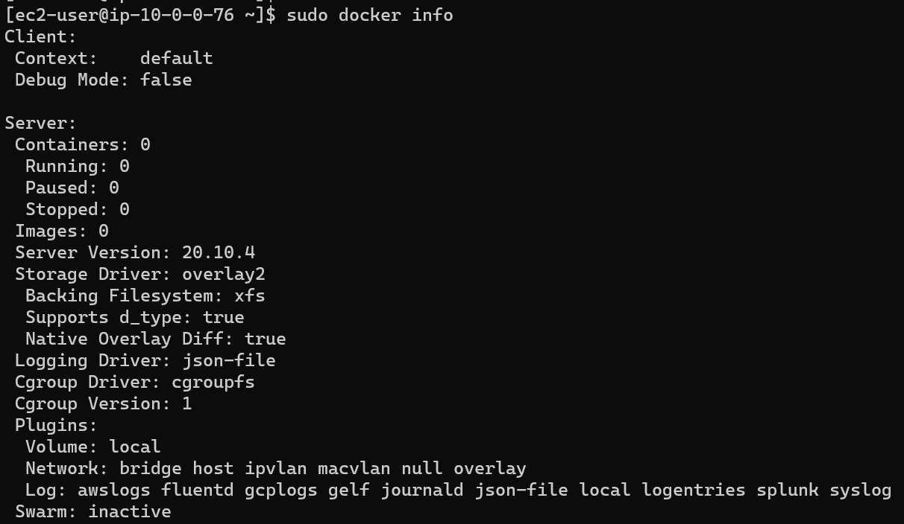

## Install sonarqube docker.

1. docker run -d --name sonarqube -p 80:9000 sonarqube
2. Connect to http://<your_server_public_DNS>:80 from your favorite browser
3. Account: admin Pass:admin

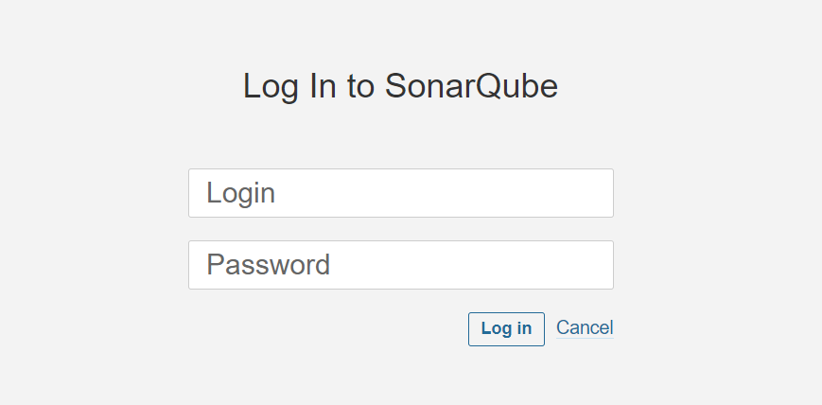

1. Login.
2. Add Project.
3. Create a Key With the name: [DevOps-Project](http://35.193.80.125/dashboard?id=DevOps-Project)

# Install [JDK11.](https://stackoverflow.com/questions/55243120/jenkins-add-jdk-11-to-jdk-list)

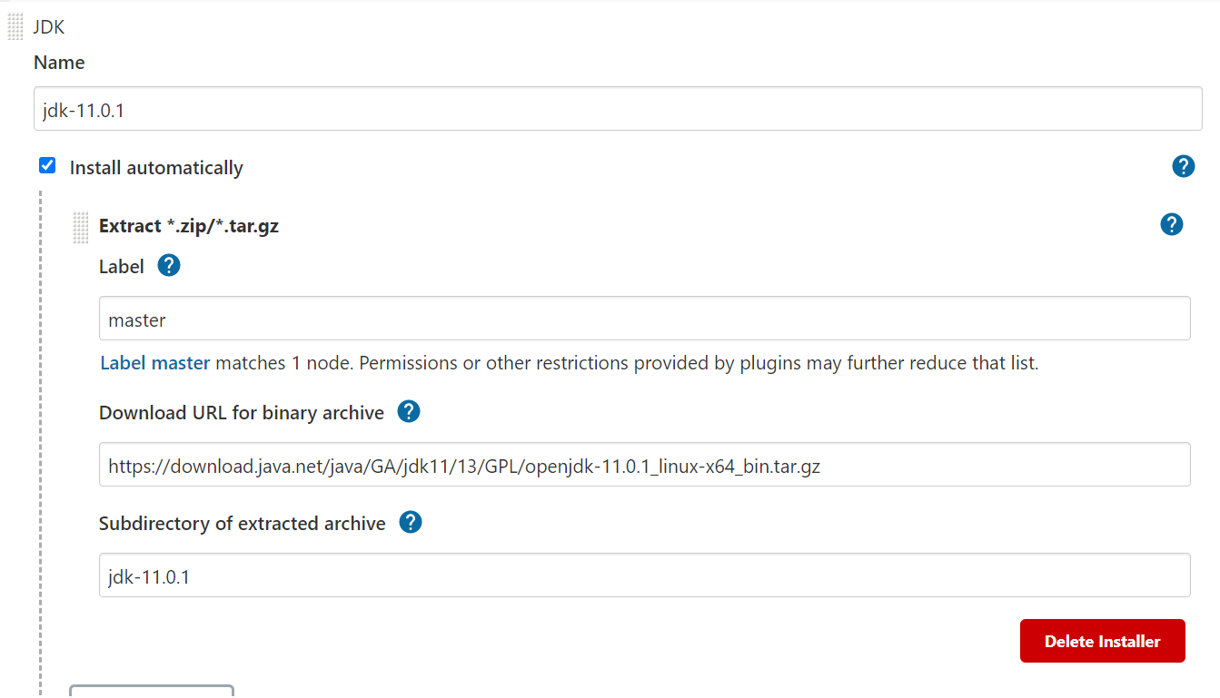

URL: https://download.java.net/java/GA/jdk11/13/GPL/openjdk-11.0.1_linux-x64_bin.tar.gz

# Link [SonarCloud](https://www.youtube.com/watch?v=atVoCmh97pc&t=672s)

1. Go to Jenkins, install Plugin:

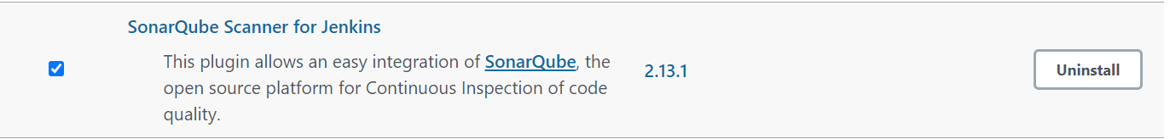

1. Go to Global tool configuration and add:

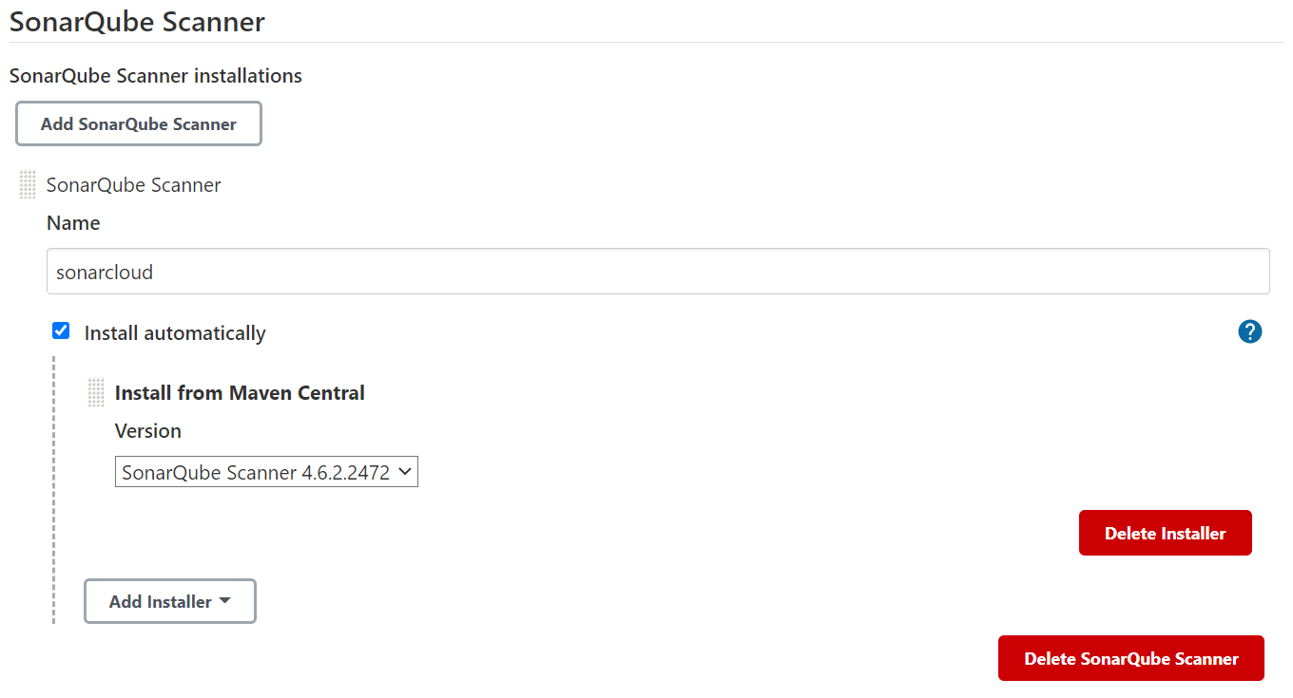

1. Go to configure system and add: Server URL of SonarQube

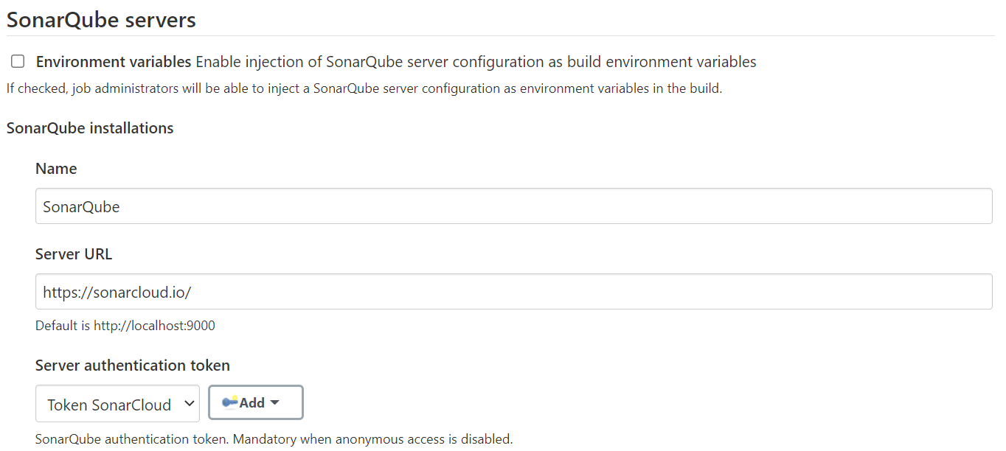

1. Add Authentication token

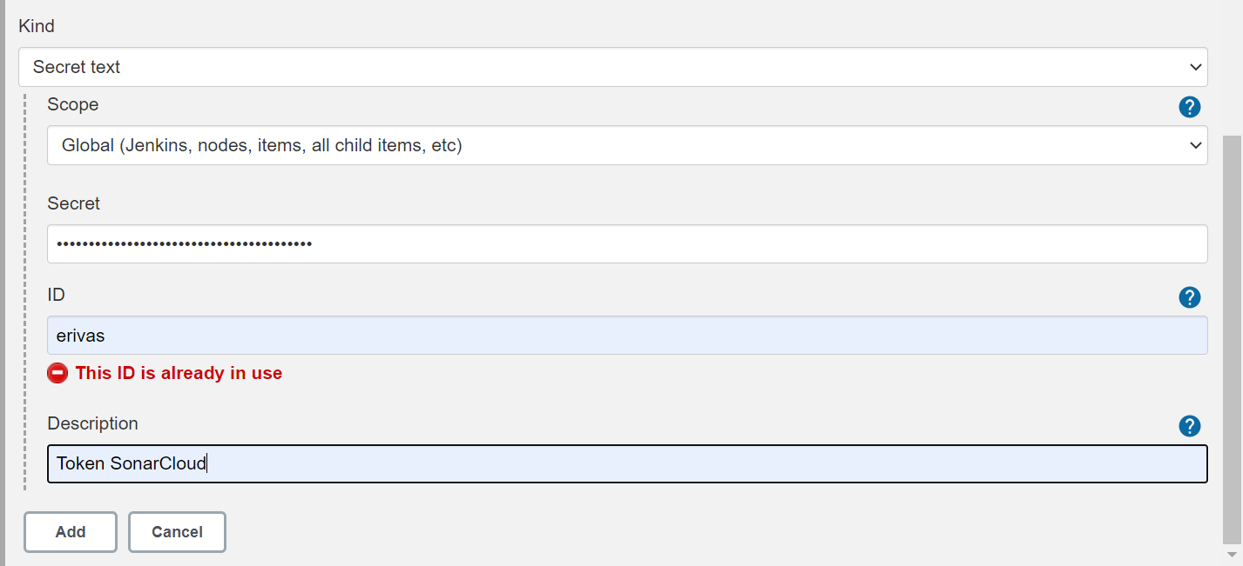

1. Go to configuration of your project and add in the Build section:

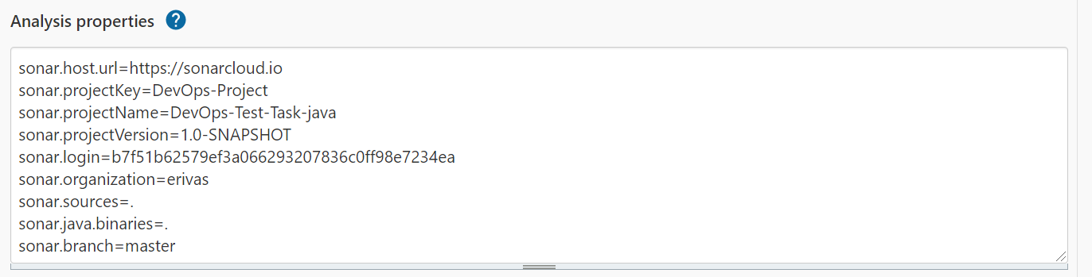

sonar.host.url=https://sonarcloud.io ##URL de sonarqube

sonar.projectKey=DevOps-Project ##Name of the Key project

sonar.projectName=DevOps-Test-Task-java ## Name of the project

sonar.projectVersion=1.0-SNAPSHOT ##Project version

sonar.login=b7f51b62579ef3a066293207836c0ff98e7234ea ##Key Project

sonar.organization=erivas ##SonarCloud User

sonar.sources=.

sonar.java.binaries=.

sonar.branch=master